

**Address:** 116 E Seminary Drive, Fort Worth, TX 76115

**Phone Number:** (817) 927-6600

**Hours:** Monday through Friday: 9:00 AM to 5:00 PM

Saturday: 9:00 AM – 2:00 PM

Sunday: CLOSED

**Documents needed to open an account:**

1. Social Security Card
2. I-94
3. Travel Document
4. AR-11

*See sample documents below of each document listed*

**Additional Information:**

* You will need $25.00 to open a bank account
* Call or email to create an appointment ahead of time. Walk-ins are not always able to be served.
  + [jose.m.godinez@bofa.com](mailto:jose.m.godinez@bofa.com) – Email Jose and he will assist with setting up an appointment with you



1

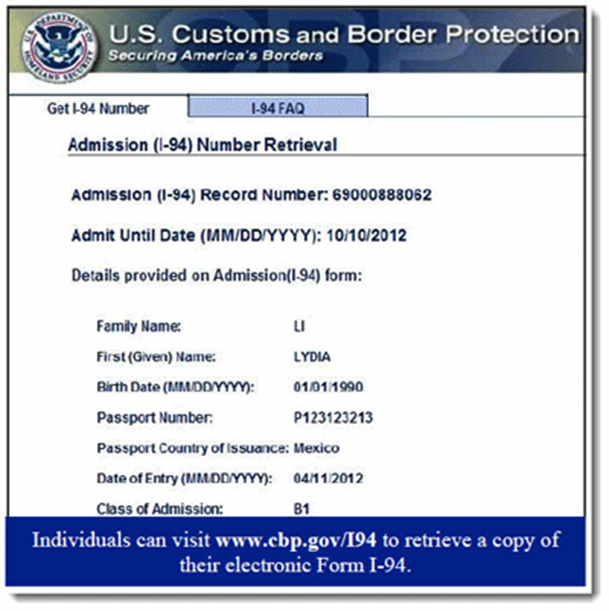

2

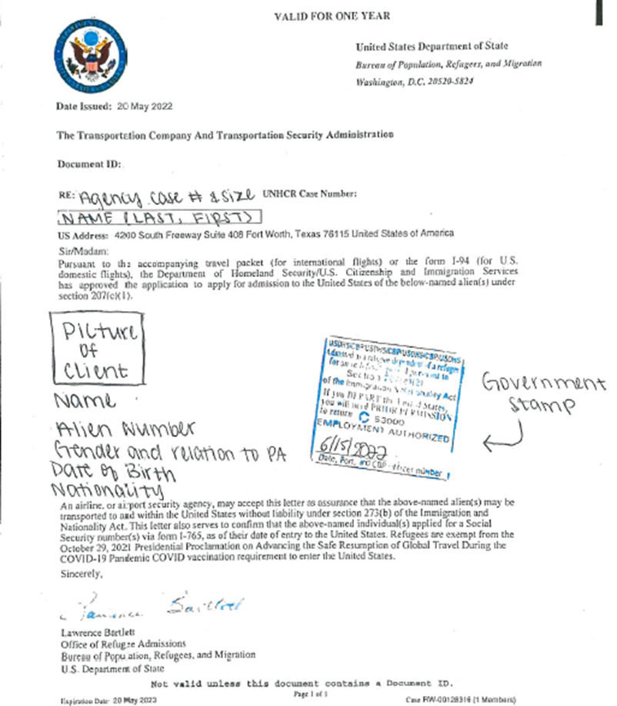

3

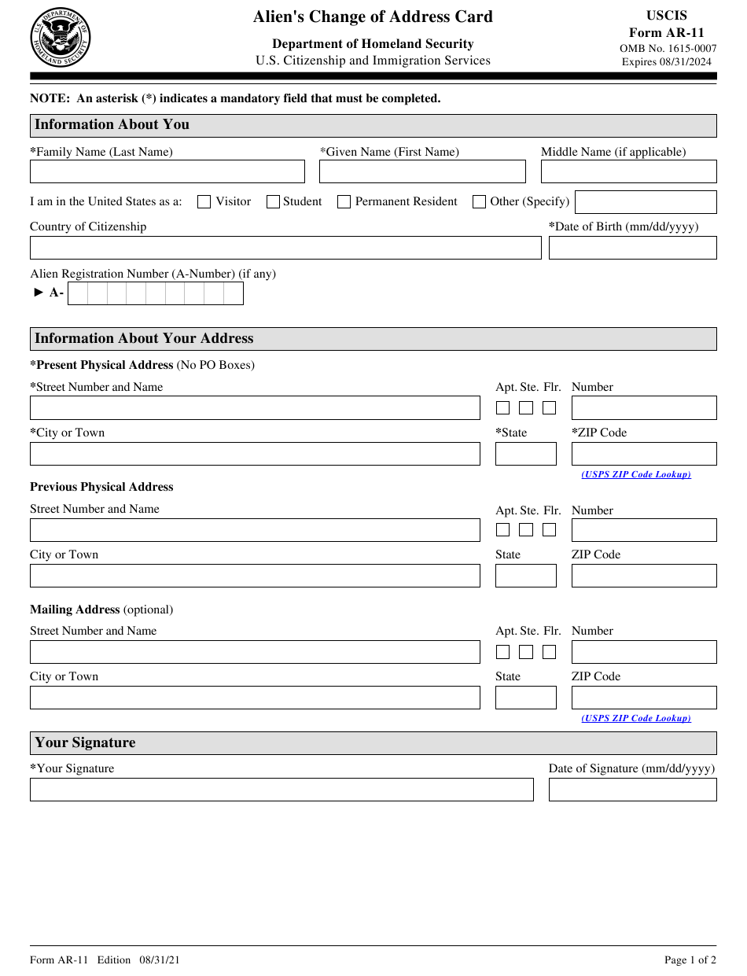

4